[294688](http://support.microsoft.com/en-us/help/294688) How to design and set up a mail merge address list in Word 2002 and in later versions of Word.

* On the **File** tab, select New and choose Blank Document.

* Click on the **Mailings** tab.

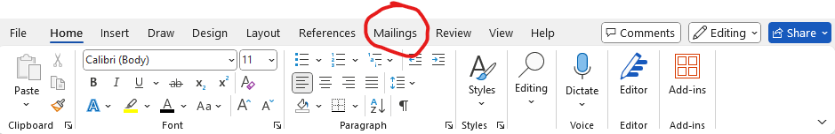

* **Select Recipients.**

* Click on **Type a New List**

* In the **New Address List** dialog box type recipient information in each column as appropriate. For more info on using the dialog box, see [Edit Data Source](https://support.microsoft.com/en-us/office/edit-data-source-dialog-db5fa4e0-eb30-47e4-827b-3a772d66b30b).

* For each new record, select **New Entry**

* If you need more columns, such as for an order number, follow these steps:
* In the **New Address List** dialog box choose **Customize Columns**.

* Choose **Add**.

* Type a field name and then select **OK**. A screenshot of a computer

  Description automatically generated
* Repeat steps b and c for each column or field to add.

When you are done adding all the people you want to your list, choose **OK**.

* In the **Save Address List** dialog box, give your new file a name, and then choose **Save**.

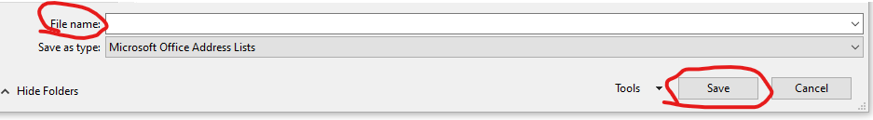

* You can now insert mail merger files into your document. For more information, see [Insert mail merge fields](https://support.microsoft.com/en-us/office/insert-mail-merge-fields-9a1ab5e3-2d7a-420d-8d7e-7cc26f26acff).

**Insert mail merge fields**

1. Word for Microsoft 365 Word for Microsoft 365 for Mac Word 2024 Word 2024 for Mac Word 2021 Word 2021 for Mac Word 2019 Word 2019 for Mac Word 2016 Word 2013
2. Once you have a data source connected to your document, adding merge fields is a way to personalize a document with information from the data source. The merged fields come from the column headings in the data source.
   1. Here is an example of how the Address Block and Greeting Line collections of merged fields might pull data from an Excel spreadsheet into a form letter:

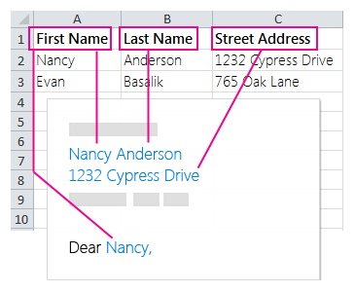

The Address Block and Greeting Line fields are collections of merged fields.

**Note:**If the merge field commands appear dimmed, click **Select Recipients,** and choose the kind of mailing list you are using. If you do not have a mailing list yet, click **Type New List** to create your list in Word.

**Add an Address Block**

1. Click or tap where you want to add the address block in your document.
2. On the **Mailings** tab, choose **Address Block**

Word gives you options for choosing the formality of the name in the address.

**Add a Greeting Line**

1. Click or tap where you want to add the greeting in your document.
2. Choose **Greeting Line**.
3. Choose the name style that you want to use and set other options.

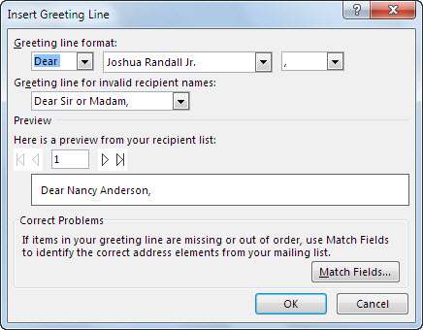

**Add individual merger fields**

1. To include data like phone numbers or email addresses, you insert those merge fields specifically. Also, a merger field like First Name does not have to be part of an Address Block or Greeting Line. If you want to personalize a document by including your recipients' first names, insert the First Name merge field on its own.
2. Click or tap where you want the merger field. Choose the down-arrow under **Insert Merge Field** and select a field.

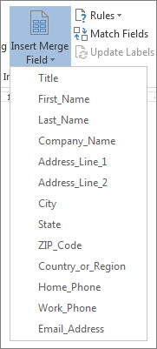

1. If you do not see your field name on the list, choose **Insert Merge Field**.
2. Choose **Database Fields** to see the list of fields that are in your data source.
3. Choose **Insert**.

**Note:**If some of the numbers, currencies, or dates are not formatted right, see [Prepare your Excel data source for a Word mail merge](https://support.microsoft.com/en-us/office/prepare-your-excel-data-source-for-a-word-mail-merge-2d802b6b-a3a3-43e5-bb76-2cac7c68673e).

**Use rules for more sophisticated personalization**

* You might want your message to differ, depending on data in certain fields of your data source. For example, invoices could include the words "Past Due" for customers where the value of the Due Date field is a date in the past.
* This level of sophistication depends on setting up rules and field codes. On the **Mailings** tab, in the **Write & Insert Fields** group, choose **Rules**, and select the kind of rule you want to add.

*For more information about how you can use mail merge rules, see [Set the rules for a mail merge](https://support.microsoft.com/en-us/office/set-the-rules-for-a-mail-merge-d546ee7e-ab7a-4d6d-b488-41f9e4bd1409).*

*Set up a new mail merge list with Word

[https://support.microsoft.com/en-us/office/set-up-a-new-mail-merge-list-with-word- 1a752328-b1b5-4865-96a2-e0acd561fe6f?ui=en-us&rs=en-us&ad=us](https://support.microsoft.com/en-us/office/set-up-a-new-mail-merge-list-with-word-1a752328-b1b5-4865-96a2-e0acd561fe6f?ui=en-us&rs=en-us&ad=us)